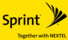

Sprint Nextel (2005)



Sears Holdings Corporation (2005)

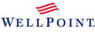

WellPoint (2004)

Air France-KLM (2004)

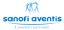

Sanofi-Aventis (2004)

The Travelers Companies (2004)

Mizuho Financial Group (2003)

Japan Post (2003)

Medco Health Solutions (2003)



Tengelmann (2002)

Coop Norden (2002)

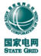

State Grid (2002)



ConocoPhillips (2002)

AOL Time Warner (2001)

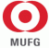

Mitsubishi UFJ Financial Group (2001)

BHP Billiton (2001)



AmerisourceBergen (2001)



EADS (2000)

GlaxoSmithKline (2000)

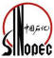

Sinopec (2000)

Vivendi Universal (2000)

JPMorgan Chase (2000)

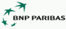

BNP Paribas (2000)

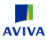

Aviva (2000)

E.ON (2000)



Visteon (2000)



Exelon (2000)

Exxon-Mobil (1999)

UniCredit (1999)



AstraZeneca (1999)

BAE Systems (1999)



AutoNation (1999)

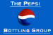

Pepsi Bottling (1999)



Health Net (1998)



Sempra Energy (1998)

HypoVereinsbank (1998)



KBC Bank (1998)

Fortum (1998)

PricewaterhouseCoopers (1998)



Google (1998)

Citigroup (1998)

DaimlerChrysler (1998)



CHS, Inc. (1998)

Delphi (1997)



Alliance Unichem (1997)

Cendant (1997)

FirstEnergy (1997)



Deutsche Telekom (1996)



Qwest Communications International (1996)



Lockheed Martin (1995)



Constellation Energy (1995)

Deutsche Post (1995)



Deutsche Bahn (1994)

Northrop Grumman (1994)



DirecTV Group (1994)

Burlington Northern Santa Fe (1993)

Caremark Rx (1993)



Plains All American Pipeline (1993)

ING Group (1991)

Ernst & Young (1989)



Gazprom (1989)

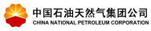

China National Petroleum (1988)

Capital One (1988)



KPMG (1987)

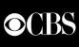

CBS Corporation (1986)

Office Depot (1986)



Staples (1986)



Express Scripts (1986)

Nippon Life Insurance (1985)



AXA (1985)

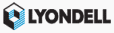

Lyondell Chemical (1985)



Nippon Telegraph & Telephone (1985)

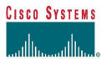

Cisco (1984)

Verizon Communications (1983)

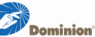

Dominion Resources (1983)

BellSouth (1983)

Costco (1983)

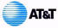

AT&T (1983)

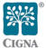

Cigna (1982)

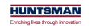

Huntsman (1982)

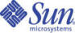

Sun Microsystems (1982)



AMR (1982)

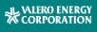

Valero Energy Corporation (1980)



Newscorp (1980)

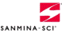

Sanmina-SCI Corporation (1980)

Amgen (1980)

Ingram Micro (1979)

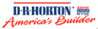

D. R. Horton (1978)

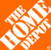

Home Depot (1978)

Oracle (1977)



UnitedHealth Group (1977)

PSA Peugeot Citroën (1976)

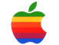

Apple Inc. (1976)

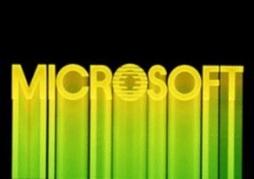

Microsoft (1975)

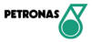

Petronas (1974)

Tech Data (1974)

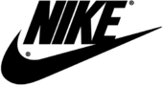

Nike (1972)

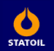

Statoil (1972)

Nucor (1972)



Cardinal Health (1971)



FedEx (1971)

Airbus (1970)

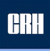

CRH plc (1970)

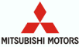

Mitsubishi Motors (1970)



SYSCO (1969)

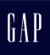

GAP (1969)

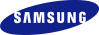

Samsung Electronics (1969)

Centex (1969)

Countrywide Financial (1969)

Intel (1968)



Hospital Corporation of America (1968)

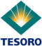

Tesoro (1968)

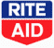

Rite Aid (1968)

Bank of America (1967)

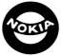

Nokia (1967)



Best Buy (1966)

Berkshire Hathaway (1965)

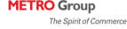

Metro (1964)



Comcast (1963)

CVS Corporation (1963)

Koç Holding (1963)

Walmart (1962)



Electronic Data Systems (1962)

Kohl's (1962)

Humana (1961)

Tyco International (1960)

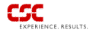

Computer Sciences Corporation (1959)

LG (1958)

Carrefour (1957)



TJX (1956)



Aflac (1955)

Lennar (1954)

Mitsubishi (1954)

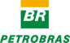

Petrobras (1953)

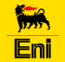

Eni (1953)

All Nippon Airways (1952)

General Dynamics (1952)

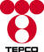

The Tokyo Electric Power Company (1951)

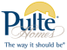

Pulte Homes (1950)



Murphy Oil (1950)

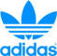

adidas (1949)

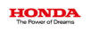

Honda Motor (1948)

Manpower (1948)

Sony (1946)

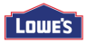

Lowe's (1946)



Bombardier (1942)

Koch Industries (1940)

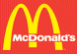

McDonald's (1940)



Albertsons (1939)

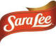

Sara Lee (1939)

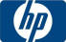

HP (1939)

ICA (1938)

Fannie Mae (1938)

Toyota Motor (1937)



Volkswagen (1937)

Progressive (1937)



Morgan Stanley (1935)

Nissan Motor (1932)

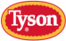

Tyson Foods (1931)

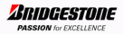

Bridgestone (1931)



Allstate (1931)

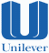

Unilever (1930)



Publix Super Markets (1930)

Masco (1929)

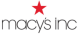

Macy's, Inc. (1929)

United Technologies (1929)

Delta Air Lines (1928)

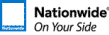

Nationwide (1926)

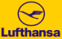

Lufthansa (1926)

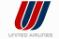

UAL (1926)

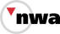

Northwest Airlines (1926)

Coca-Cola Enterprises (1926)

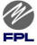

FPL (1925)

Caterpillar (1925)

Tesco (1924)

Total (1924)

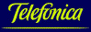

Telefónica (1924)

Textron (1923)



USAA (1922)



State Farm Insurance (1922)

Raytheon (1922)

Disney (1922)

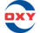

Occidental Petroleum (1920)



ConAgra Foods (1919)

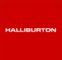

Halliburton (1919)

American International Group (1919)

Loblaw Companies (1919)

Hess Corporation (1919)

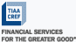

TIAA-CREF (1918)

Matsushita Electric Industrial (1918)



Anglo American (1917)

Lear (1917)

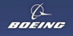

Boeing (1916)

Safeway (1915)

Merrill Lynch (1914)



Loews (1913)

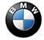

BMW (1913)

Illinois Tool Works (1912)

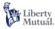

Liberty Mutual Ins. Group (1912)

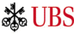

UBS (1912)

Mars (1911)

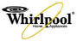

Whirlpool (1911)



IBM (1911)



Hitachi (1910)

Vattenfall (1909)

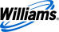

Williams Companies (1908)



BP (1908)

Wachovia (1908)

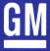

General Motors (1908)

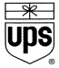

United Parcel Service (1907)



Royal Dutch Shell (1907)

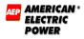

American Electric Power (1906)

Xerox (1906)

ONEOK (1906)

Honeywell (1906)

PACCAR (1905)

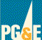

PG&E (1905)



Marsh & McLennan Companies (1905)

Norsk Hydro (1905)



A.P. Moller-Maersk Group (1904)

Duke Energy (1904)

Toshiba (1904)

TRW Automotive Holdings (1904)

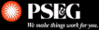

PSE&G (1903)

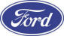

Ford Motor (1903)



Pepsi (1903)

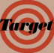

Target Corporation (1902)



Archer Daniels Midland (1902)

3M (1902)

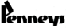

J.C. Penney (1902)

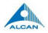

Alcan (1902)

Walgreens (1901)

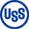

U.S. Steel (1901)

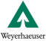

Weyerhaeuser (1900)

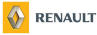

Renault (1899)

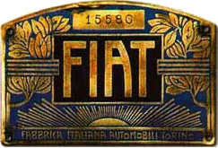

Fiat (1899)

International Paper (1898)



RWE (1898)

Goodyear Tire & Rubber (1898)

Edison International (1897)

Dow Chemical Company (1897)

Hoffmann–La Roche (1896)

Barclays plc (1896)

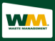

Waste Management (1894)

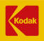

Eastman Kodak (1892)

Merck & Co. (1891)



Philips (1891)

U.S. Bancorp (1890)



Emerson Electric (1890)

Fluor (1890)

Allianz (1890)

Washington Mutual (1889)



Michelin (1888)

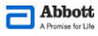

Abbott Laboratories (1888)

Bristol-Myers Squibb (1887)



Marathon Oil (1887)

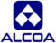

Alcoa (1886)

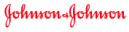

Johnson & Johnson (1886)



Sunoco (1886)

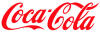

Coke (1886)



Johnson Controls (1885)

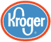

Kroger (1883)

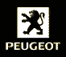

Peugeot (1882)



Munich Re (1880)



The Linde Group (1879)

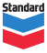

Chevron (1879)

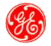

GE (1878)

Lilly (1876)

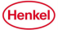

Henkel (1876)

Prudential Financial (1875)

Kimberly-Clark (1872)

Continental (1871)

Deutsche Bank (1870)

Supervalu (1870)

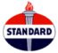

Standard Oil (1870-1911)

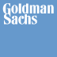

Goldman Sachs (1869)

Deere & Company (1868)

Metropolitan Life Insurance Company (1868)

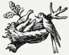

Nestlé (1866)

HSBC Holdings (1865)



Cargill (1865)

BASF (1865)



Bayer (1863)

Swiss Re (1863)



Union Pacific Railroad (1862)

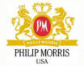

Altria Group (1860)

Wyeth (1860)

Northwestern Mutual (1857)

Credit Suisse (1856)



Telenor (1855)

Veolia Environnement (1853)



Wells Fargo (1852)

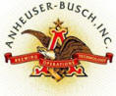

Anheuser-Busch (1852)

MassMutual (1851)



Aetna (1850)

Lehman Brothers (1850)

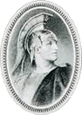

American Express (1850)

Deloitte Touche Tohmatsu (1849)

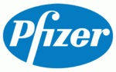

Pfizer (1849)



Siemens (1847)

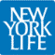

New York Life Insurance Company (1845)

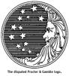

Procter & Gamble (1837)

Celesio (1835)

McKesson (1833)

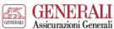

Assicurazioni Generali (1831)

Consolidated Edison (1823)

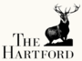

The Hartford (1810)

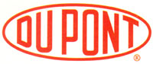

DuPont (1802)

Bank of the Manhattan Company (1799)

United States Postal Service (1775)

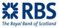

Royal Bank of Scotland (1727)

the Mississippi Company (1717)

Hudson's Bay Company (1670)

the French East India Company (1664)

the Virginia Company (1606)

the Dutch East India Company (March 20, 1602) was the first
multinational corporation and the first company to issue stocks in the world

the British East India Company (1600)

Rolo Banca (1473)
the Medici Bank (1397-1494)

